Open Shift Container Storage:

Prerequisites:
1. Operator SDK
2. OLM
3. CSV
4. Controllers and Operators.

Steps to run OCS operator locally (for running master or any other test branch)
Creation: Note: The cluster type should be m5.4xlarge
1.Add appropriate labels to the Nodes for running ocs pods by using sh file.
2.Update (Export) the appropriate images (rook, nooba etc) that you want to use in /hack/generate-latest-csv.sh
3.Run make gen-latest-csv
4.Run make ocs-registry. This will create quay.io/ocs-dev/ocs-registry.
Push this image to your docker repo.
5.Add the pushed image to deploy/deploy-with-olm.yaml file on line 65.
icon: base64data: "" mediatype: "" #image: quay.io/ocs-dev/ocs-registry:latest image: docker.io/sp1098/ocs-test publisher: Red Hat
6. Start operators by running deploy/deploy-with-olm.yaml
7. Wait for CSV to be created. By checking - oc get csv -n openshift-storage
8. Add storagecluster - deploy/crds/ocs_v1_storagecluster_cr.yaml

Flow:
- Reconcile Flow:
- Reconcile re-queues the request if error is returned or if re-queue variable is true.
- Get the storageCluster API instance
- Get the storagecluster Object running on the K8s cluster and update the above API instance.
- Check the version of the storageCluster instance. If empty, then update with the version constant. If not, then make sure that the version mentioned in the instance spec is not higher than that in the version constant (semantic version is compared for this)
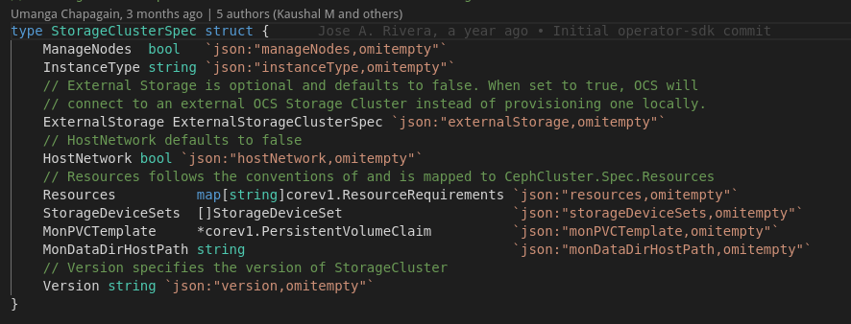
--------------------------------------------
- Status.Phase is the Phase the OLM is using the show the current phase of the cluster in the UI
- If the storageCluster phase is not set (its empty) then:
- Check if the storageCluster instance is active or not: (Active means currently running cluster)
A) its not active if there is a deletionTimeStamp on it.
B) its active there is only one storageCluster object instance available in the storageClusteList.
C) if there are multiple storageCluster objects, then current cluster is not active if :
- there is another storage cluster in the list (with different name) that doesn’t have phaseIgnored, has empty phase, was created before current cluster instance, or created at the same time but name is apathetically lower than the current instance.

Basically, if a cluster is already active and if a user tries to create a new cluster (like from CLI), then new cluster will be marked as “ignored” and never run again!
(TO TRY)

---?? is the cluster with phaseignored never run again?

- If not active, then change the phase to phase ignored and then update the cluster instance and return with no error. (so no reconcile)
- If the phase is already phase ignored, then return without error (so no reconcile)
---------------------------------------------

- Validate the storageDeviceSets in the storageCluster instance. It should not have an empty 'StorageClassName'. This validation is not done if external storage is not enabled.

--------------------------------------------
- Start the new storagecluster instance with phase as "progressing" if it's not already in any other phase like ready, expanding or deleting, connecting or connected phase.

--------------------------------------------
- If conditions are not set on the storagecluster Instance, that is, its a new cluster, then set conditions to it.

-------------------------------------
Add Finalizers:
- If StorageCluster is not being deleted (does not have a deletiontimeStamp), then check if it has finalizers or not. If not, then add the "storagecluster.ocs.openshift.io" finalizer to the StorageCluster and Update it.

--------------------------------------
Remove finalizers:
- If storagecluster has a deletionTimeStamp, then
a) First update the StorageCluster phase to deleting.
b) Then remove the noobasubsystem
c) then remove the finalizers (which will then delete the cluster)
-------------------------------------------

- Reconcile Node Topology map: (not supported in case of external storage)
- Objective: Create a NodeTopologyMap and update it in the StorageCluster.Status.NodeTopologies
- Format:
NodeToplogyMap {
Labels: map[string]TopologyLabelValues
}

TopologyLabelValues [] string

1) Set minNodes to either StorageDeviceSets.Replica or defaulSetReplica value, whichever is greater.
2) Number of nodes available should be greater than this minNode count. Else return with error. In other words if the users gives the StoreageDeviceSet.Replica value greater then number of nodes in the cluster, then return an error.
3) create instance of the NodeList and update it with the available nodes in the cluster using having the node affinity cluster.ocs.openshift.io/openshift-storage="".
4) create a new node topology map and assign it to the cluster NodeTopologies if its nil.
- Update ToplogyMap:
1) For all node labels, if a label matches with any key in the validTopologyLabelKeys list, then add the label and value to the newly created ToplogyMap if it's not already present.
- Update Node Racks Map:
1) For all the node labels, if the label matches with string "rack", then update the nodeRacks map.
2) If failure domain is RACK then run `ensureNodeRacks' funtion
- If the nodeTopologyMap was updated above, then update the StorageCluster with this updated topologyMap
--------------------------------------
- Storage Cluster Initialization:
- Objective: Set the status of the all the dependent resources to ‘False’ and in the StorageCluster to ensure that all these resources are reconciled.
- Note: StoreageClusterIntialization API has empty spec and status
- Create an instance of StorageClusterIntialization and try to update it with an existing storageClusterIntialization object running in the k8s cluster.
- If the storageClusterIntialization Cluster is not found, then it means we are creating it for the first time. In that case, update the storageCluster instance status for StorageClassCreated, CephObjectCreated, CephBlockPoolsCreated, CephObjectStoreUsersCreated, CephFileSystemsCreated to false. And also update the failure domain.
- Update the name and namespace of the StorageClassIntialization instance.
- Set the controller reference ???
- Create the storageClassInitialization instance

------------------------------------------
- Update reconciler conditions to nil.
- Update reconciler phase as empty.
- Run functions to Create
a) Ceph Storage Classes.
b) Ceph Object Stores. (not in case of AWS)
c) Ceph Object Store Users (not in case of AWS)
d) Ceph File Systems
e) Ceph Block Pools
f) Ceph Config
g) Ceph Cluster
h) Nooba System
Note: only ensure ceph cluster if external storage is enabled
- Creation of all the above has a common pattern.
- First check if resource is already created or not (this can be found by instance.Phase.<Resource>Created). Do nothing if the created phase is true.
- If not created already then create the resource instance (the yaml file).
- Create instance of this resource to see if an existing resource is available or not.
- if an existing resource is found then update it only if there is no deletionTimeStamp, else do nothing.
- if no existing resource is found then create one.
- Update the phase of the storageCluster instance after each resource is created.
- if reconciller is cluster expanding then update the instance phase to cluster expanding.
- if instance is not phase ready, then update instance to phase progressing
- If creation of any of the resources above fails, then adding reconcile failed condition to the instance and return error.

--------------------------------------------------------------------
- Once all the resources are created, check if conditions is nil (that is, none of the resource creation failed)
- If conditions are nil, then
a) add complete condition to the instance.
b) set readiness probe.

- If conditions are not nil (that is one or more operator failed)
a) add the reconciler conditions to the storeagecluster
b) add reconcile completed message and reason.
c) unset readiness if we marked ourself as unupgradable.
c) if the cluster is not expanding, then update the instance to :
1. phase progressing if one of the reconciler condition is progressing.
2. phase not ready if we set one of the conditions to unupgradable

- Ensure Ceph Cluster: To create or update the ceph cluster.
- Get all the storageClassDeviceSets and for each, update the config.TuneSlowDevices to true only if provisioner is EBS and type is ‘gp2’ or ‘io1’. Because these are slow devices.
- Create a new cephCluster instance and make it owner and controller.
- Check if any existing cephCluster is found or not.
- If no existing cephCluster is found, then we simply create one and return.
- If an existing cephCluster is there then we check if it should be updated or not by:
a) Compare the storageClassDeviceSet counts for both new and existing cluster.
b) Compare the actual count for each storageClassDeviceSets in the new and existing cluster.
- If any of ‘a’ or ‘b’ above is true, then we just update the existing cluster spec with the new cluster spec and update the cephCluster.
- Add it to the list of related objects ???

----------------------------------------------------------------------
EnsureCephCluster:
Objective: Create or update the cephCluster CR
- There should be no storageClassDeviceSets when external cluster is enabled.
- If the storage provisioner is AWS EBS and type is gp2 or io2 then set the StorageClassDeviceSet.Config.TuneSlowDeviceClass to True else to False.
- Generate the cephCluster Spec.
- Create the ceph Cluster only if its not already present.
- If ceph Cluster is already found, then check if needs to up updated by comparing both the new and existing spec of the ceph cluster.
- Updates on the spec can be in the StoreageClassDeviceSets like:
1- Existing StorageClassDevicSets count is less then new one.
2- One Particular StorageClassDeviceSet has different count in new and existing cluster.
In both the cases, we update the reconciler phase to ‘PhaseClusterExpanding` and update the cephCluster.

- Update the reconciler conditions based on the how conditions change in cephCluster
- If the cephCluster (found) status.State is empty update the reconciler conditions with no conditions state).
- If the ceph Cluster (found) status.State is not empty, then update reconciler conditions appropriate conditions based on the state
- if storage cluster phase is expanding and ceph cluster state is not updating then update the reconciler phase to expanding

--------------------------------------------------------------------------------------------------------

newStorageDeviceClassSets:
Objective: Use the StorageCluster StorageDeviceSets spec to create the StorageClassDeviceSet spec in ceph Cluster

StorageDeviceSet:
type StorageDeviceSet struct {
// Count is the number of devices in each StorageClassDeviceSet
// +kubebuilder:validation:Minimum=1
Count int `json:"count"`

// Replica is the number of StorageClassDeviceSets for this
// StorageDeviceSet
// +kubebuilder:validation:Minimum=1
// +optional
Replica int `json:"replica,omitempty"`

// TopologyKey is the Kubernetes topology label that the
// StorageClassDeviceSets will be distributed across. Ignored if
// Placement is set
// +optional
TopologyKey string `json:"topologyKey,omitempty"`

// Portable says whether the OSDs in this device set can move between
// nodes. This is ignored if Placement is not set
// +optional
Portable bool `json:"portable,omitempty"`

Name string `json:"name"`
Resources corev1.ResourceRequirements `json:"resources,omitempty"`
Placement rookalpha.Placement `json:"placement,omitempty"`
Config StorageDeviceSetConfig `json:"config,omitempty"`
DataPVCTemplate corev1.PersistentVolumeClaim `json:"dataPVCTemplate"`
}

Rook StorageClassDeviceSet:

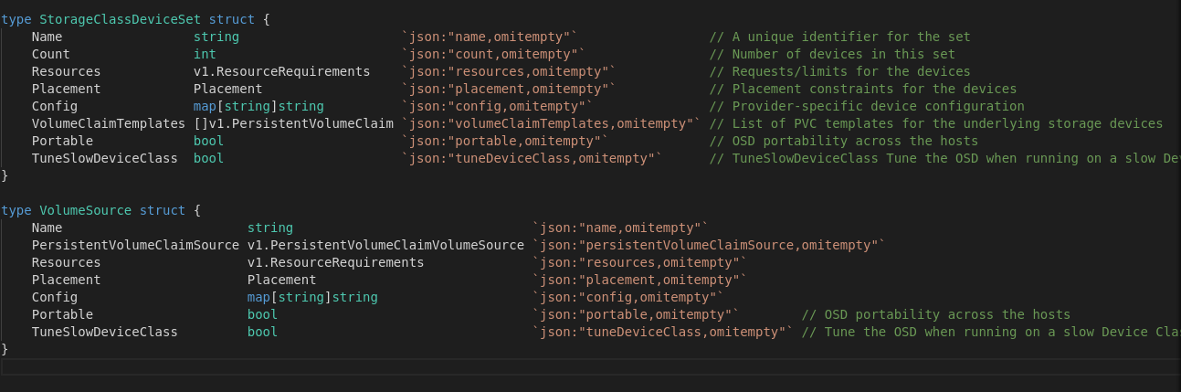

- Understand how placements are set in this method.

---------------------------------------------------------------------------------------------------

ensureStorageClasses:
- Objective: Creates 2 storage classes – Ceph File System Storage Class and Ceph Block Pool Storage class.
- If the ‘StoreageClassCreated’ param in the StorageCluster Status is already true then do nothing.
- Create StorageClass Spec for both Ceph Files system and Ceph Block Pool.
- For both the storage classes:
1. if the storage class is not found then create it.
2. If the storage class is found :
- return error if deletionTimeStamp is present on it ???
- else update the existing storage class.

- Update the “storeageClassCreated” to true in the storageClusterStatus
Understand the storage class spec.

---------------------------------------------------------------------------------------------------
ensureCephObjectStores:
- Objective: Create ceph object stores.
- If “CephObjectStoresCreated” status is true then do nothing.
- If platform is AWS then don’t create ceph Object store. ??? (by why)
- Create new ceph Object store instances spec.
- For each object store instance:
1. Create if object store is not found.
2. If object store is found:
- Return error if deletionTimeStamp is present on it. ???
- Else update the existing Object store.

- Update the “CephObjectStoresCreated” to “true” in the storagecluster status
To Do: Understand the Object Store in ceph.

----------------------------------------------------------------------------------------------------
ensureCephObjectStoreUsers:
- Objective: create ceph Object store users.
- If “cephObjectStoreUsers” status is true then do nothing.
- If platform is AWS then do nothing and return.
- Create the ceph Object store users spec.
- For each Ceph Object store user instance:
1. Create if object store user instance is not created.
2. If Object store user is already created then :
- Return error if deletiontimeStamp is present on it ???
- else update the object store user instance.

- Update the “cephObjectStoreUser” to “True” in the storageCluster status .

To Do: Understand the object store user spec in ceph.

-------------------------------------------------------------------------------------------------
ensureCephBlockPools:
- Object: create ceph block pools
- If “cephBlookPoolsCreated” status is “true” then do nothing.
- Create new ceph Block Pools Instances.
- For each ceph block pool instance:
1. Create if the ceph block pool instance is not found in the cluster.
2. If Ceph Block Pool is already created, then:
a) Return error if deletionTimeStamp is present on it.
b) Else update the cephBlockPool instance.

- Update the “CephBlockPoolCreated” to “true” in the storageCluster status.
TO DO: understand the ceph block pool spec in ceph.

---------------------------------------------------------------------------------------------
ensureCephFileSystem:
- Objective: Create ceph Filesystem
- If the “cephFileSystemCreated” status is already “True” then do nothing.
- Create instances of the “ceph File system”.
- For each ceph file sytem instances:
1. Create if the ceph file system instance is not present.
2. If already present:
a) Return error if there is deletionTimeStamp present on it.
b) Else update the ceph file system instance.

- Update the “CephFileSystemCreated” to “true” in the storageCluster status.

To do: understand ceph File system spec in ceph

--------------------------------------------------------------------------------------------
ensureCephConfig:

OCS components used in Console:
1. StorageCluster.Status.Phase – Is used to tell the current phase of the cluster in the UI. Phase can be:
- Ignored
- Progressing
- Error
- Ready
- Not Ready
- Expanding Cluster
- Deleting
- Connecting
- Connected.

2. Conditions:
- Shows the state of the operators reconciling functionality
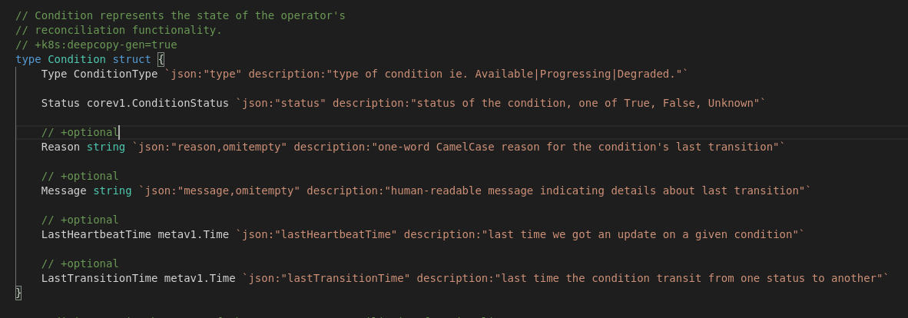
- Different status types can be :
a) Available : Resources maintained by the operator are available and functional
b) Progressing: Operator is actively making changes to the resources its maintaining.
c) Degraded: Resources maintained by the operator are not functioning completely. For example some pods are not running.
d) Upgradeable : Resources are in a state that is safe the upgrade. False means its not safe the upgrade and ‘message’ field should have a human readable message on what the human should do to allow the operator to successfully update the resources maintained by the operator.

Other than these built in conditions, OCS operator also uses ReconcileComplete condition.

